Lebanese American University


MEE 342 – Kinematics of Machines

Dr. Carine Habchi

Kinematics Project

Maria Al Sayed 202300293
Ghadi Ammar 202304235
Ali Ismail 202302900
Elie Mina 202301645
04-08-2026

Table of Contents
Table of Tables 4
Table of Figures 5
Introduction 6
Design Analysis 7
1. Original Design Concept from the Research Paper 7
2. Description of the SolidWorks Design 8
3. Mechanism Type and Degree of Freedom 8
4. Kinematic Analysis 9
5. Material Selection 9
6. Limitations of the Current Design 10
7. Conclusion 10
Motion Control 11
Methodology and Implementation 11
1. System Overview 11
2. Forward Kinematics Derivation 11
3. Tail Kinematics 12
4. Implementation 12
5. Velocity Estimation and Propulsion 13
6. Results and Interpretation 13
7. Discussion 13
Symmetric Motion Case (Forward Motion) 14
Non-symmetric Motion Case (Turning Motion) 15
1. Reduction of the Collinearity Constraint 15
2. Mean Oscillation Angle 15
3. Decoupling of Propulsion and Steering 15
Hardware and Programing Implementation 17
Hardware 17
Programing and Control Algorithm 17
1. Encoder Feedback 17
2. Motor 1 with Speed PID 18
3. Motor 2 with Cascaded Position–Speed PID 18
4. Control Modes and Sequence 18
Conclusion 19
References and Links 20

Table of Tables
Table 1: Selected Part Material 9

Table of Figures
Figure 1: Fish Robot Rendered Image 7
Figure 2: Reference 2-DoF Actuation Concept and The Adapted SolidWorks Linkage Layout 8
Figure 3: Coordinate systems and kinematic parameters of the fish robot 14
Figure 4: CAD Model of the Dual-Crank Reel Mechanism for Tail Actuation 14
Figure 5: Circuit Design 17

Introduction
Robotic fish have attracted significant attention for their biomimetic design and applications in environmental monitoring, biological surveys, and underwater exploration. Unlike propeller-driven systems, which generate noise and disturb marine ecosystems, robotic fish provide efficient and less intrusive locomotion. This project builds on the work of Wang et al. (2026) by focusing on the kinematic modeling of a wire-driven fish equipped with a 2-DoF crank-slider mechanism. The design decouples propulsion from steering, enabling both high swimming speed and agile maneuverability. While the original study employed servo-based continuous rotation control, our project simplifies the system using budget-friendly components and replaces the motor control with an encoder based PID algorithm. This ensures smooth, accurate motion while retaining the core crank-slider actuation and robotic system architecture.

Design Analysis
In this section, we will go through the analysis of the Biomimetic Fish Robot Based on a Modified 2-DoF Crank-Slider / Slotted Crank-Rocker Mechanism.
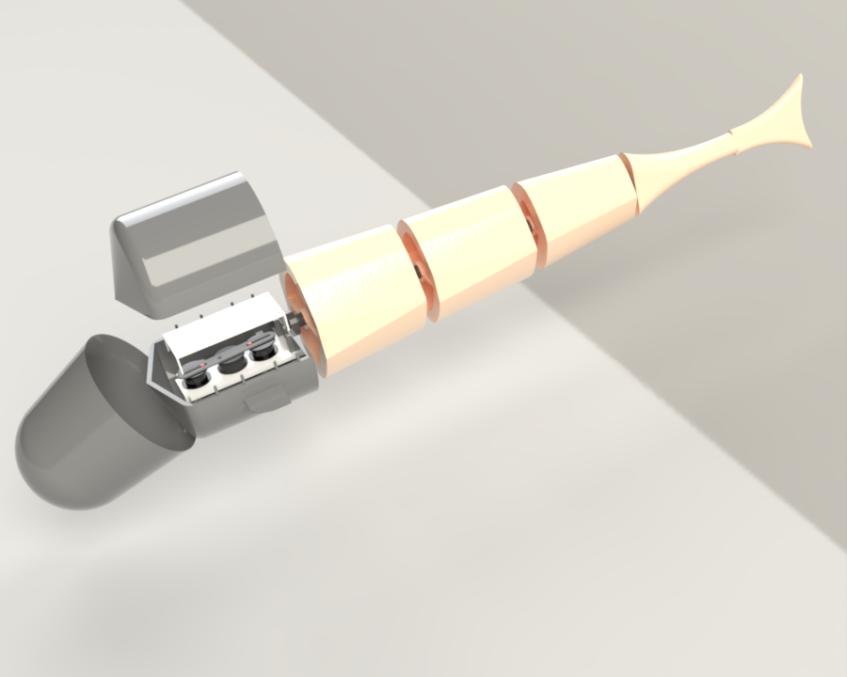
Figure 1: Fish Robot Rendered Image

Original Design Concept from the Research Paper
The original robotic fish consists of a rigid head shell, segmented rear body, elastic spine, driving wire, pectoral fins, and passive caudal fin. The rigid head contains the actuation mechanism and electronics, while the rear body bends to generate fish-like swimming motion.
The actuation mechanism in the paper contains two independently controlled driving wheels connected to a slotted rod and reel. The reel drives a wire connected to the tail. The main advantage of the mechanism is that it can operate in symmetric and asymmetric modes. In symmetric mode, both motors rotate together to produce forward propulsion. In asymmetric mode, one motor can create a mean tail offset while the other provides continuous oscillation, allowing turning motion.
The original prototype used compact DYNAMIXEL servo motors, a PLA body and head, SUS304 stainless steel linkage components, a silicone waterproof skin, and an elastic urethane spine. The paper reports that the prototype was 502 mm long, 83 mm wide, 128 mm high, and had a mass of 2050 g.
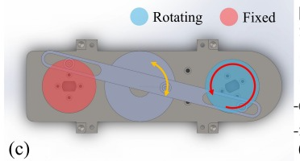
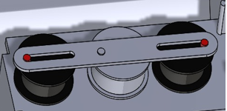
Figure 2: Reference 2-DoF Actuation Concept and The Adapted SolidWorks Linkage Layout

Description of the SolidWorks Design
The SolidWorks model follows the same general fish structure as the paper but includes important changes to fit the available components. The design contains a deeper front tub, internal gears, DC motors, a slotted rocker linkage, segmented cylindrical body parts, and a tail fin. The main design focus was packaging the actuation mechanism inside the head while maintaining the external appearance of a fish.
The head tub is the main mechanical housing. It supports the motors, gears, shafts, rocker link, and cover. Since the DC motors used in this project are much taller than the servo motors in the original paper, the tub had to be significantly deeper. This modification allowed the motors to fit vertically while leaving enough clearance for the gears and moving linkage.
The final SolidWorks model has an overall length of 1051 mm, a maximum width of 190 mm, and a maximum height of 159 mm. These dimensions represent the complete assembled fish robot, including the rigid head, internal motor tub, segmented body, and caudal fin. Compared with the original paper, the overall dimensions are larger mainly because our design uses taller DC motors with encoders, which require a deeper head section to fit the motors, gears, and linkage mechanism.
The rear body was modeled as multiple streamlined segments to represent the flexible body of the fish. The caudal fin was modeled at the rear to represent the tail surface responsible for producing thrust when oscillated.

Mechanism Type and Degree of Freedom
The mechanism in the SolidWorks design is best described as a double-input slotted crank-rocker mechanism inspired by the paper's 2-DoF crank-slider system. The rotating gears or disks act as cranks. The pins on these gears slide inside elongated slots in the long central link. This long link does not rotate continuously through 360 degrees; instead, it oscillates through a limited angle. Therefore, it behaves like a rocker.
The rocker type used in this design is a slotted rocker. It is "slotted" because the crank pins move inside long slots, and it is a "rocker" because its output is limited to angular oscillation rather than full rotation.
The output of the rocker is transmitted to the elastic tail through a driving wire. One end of the wire is fixed to the reel, which is attached to the central rocker link, and the other end is fixed to the trailing section of the elastic spine. As the rocker oscillates, it winds and unwinds the wire alternately, pulling the tail from side to side and generating the oscillatory body motion required for propulsion. The wire offset distance d from the spine centerline converts the reel's angular displacement directly into the tail attack angle θₐ.
In its complete actuated form, the system has two actuated degrees of freedom because it uses two independently driven motors. The motors are independently controlled, one input can affect oscillation frequency and the other can affect the mean tail angle. However, if both motors are synchronized or if one motor is fixed while the other rotates, the mechanism behaves as an effective 1-DOF mechanism during that operating condition.
The degrees of freedom of the mechanism are verified using the Kutzbach criterion:
M = 3(n − 1) − 2j₁ − j₂
where n is the number of links, j₁ is the number of full joints (one degree of freedom each), and j₂ is the number of half joints (two degrees of freedom each). The mechanism consists of 5 links: the ground frame, the two driving cranks (gear disks), middle gear, and the central slotted rocker. It has 4 full joints: the two revolute joints at the motor shafts and the two pin-in-slot joints between the crank pins and the rocker slots. The pin-in-slot joint allows both rotation and sliding simultaneously, making it a full joint with 2 relative motions, which counts as a half joint j₂ in the Kutzbach formula. Substituting:
M = 3(5 − 1) − 2(4) − 1(2) = 12 − 8 − 2 = 2
This gives M = 2 for a dual-input system. When we set one of the motors on a bias angle. The mechanism therefore has:
M = 3(4 − 1) − 2(3) − 1(2) = 1
Hence the system will have 2 DoF in symmetric mode and 1 DoF in asymmetric mode.

Kinematic Analysis
The purpose of the internal mechanism is to convert motor rotation into oscillating tail motion. Each motor rotates a gear or disk with an offset pin. As the disk rotates, the pin follows a circular path. Since the pin is located inside a slot in the rocker, the circular motion forces the rocker to oscillate.
The operating sequence is the DC motors rotate the gears, the gear pins move inside the rocker slots, the rocker oscillates from side to side, and this oscillation can be transmitted to the tail. The resulting tail motion imitates the left-right tail beat of a swimming fish.
When both motors rotate together, the mechanism produces a more symmetric oscillation suitable for forward swimming. When one motor position is shifted or fixed while the other rotates, the output becomes biased to one side. This creates a mean tail angle and can be used for turning.

Material Selection
For a prototype, the head tub and body sections are manufactured using PLA because it is easy to 3D print and suitable for rapid prototyping.
For the linkage and rocker, a stronger material such as aluminum or stainless steel is preferred because these parts experience sliding contact and repeated oscillating loads. The original paper used SUS304 stainless steel for the actuation linkage, which is suitable because it provides good strength and corrosion resistance. But we have a 3D printed link due to a tight schedule.
The spine should be made from a flexible material such as rubber, silicone, TPU, or another compliant polymer. Table 1 summarizes the suggested material choices for the main parts of the design.
Table 1: Selected Part Material
Part | Suggested Material | Reason
Head tub / rigid shell | PLA | Easy to 3D print, rigid, suitable for prototypes
Body segments | PLA | Lightweight and simple to manufacture
Slotted rocker / linkage | Aluminum or SUS304 stainless steel | Higher stiffness and better wear resistance
Gear shafts | Steel or stainless steel | Good strength and alignment stability
Spine | TPU, rubber, or silicone | Flexible and suitable for oscillating tail motion

Limitations of the Current Design
The main limitation is the large head depth caused by using tall DC motors. This makes the design less compact than and may reduce swimming efficiency due to increased drag.
Another limitation is that although the design uses DC motors, they are equipped with encoders, which improves motion feedback and allows the motor position and speed to be monitored. This makes the system more controllable than a basic DC motor setup. However, the servo motors used in the original are more accurate.
The slotted rocker mechanism may also experience friction and wear at the sliding contacts. Bearings, bushings, or low-friction inserts could improve the motion.

Conclusion
The SolidWorks model successfully recreates the main mechanical concept of the robotic fish presented in the reference paper. The design uses a double-input slotted crank-rocker mechanism inspired by the 2-DoF crank-slider actuation system. The mechanism converts rotary input from two motors into an oscillating rocker motion that can be transferred to the tail.
The largest design difference is the actuator selection. The original research prototype used compact servo motors, while this project used taller DC motors. Because of this, the head tub had to be made much deeper to fit the motors, gears, shafts, and linkage. This caused the final dimensions of the design to differ significantly from the original paper.
The mechanism can be described as having 2 actuated degrees of freedom when both motors are independently controlled. However, it can behave as an effective 1 DOF mechanism when the motors are synchronized or when one motor is fixed. Overall, the design demonstrates a practical mechanical adaptation of the paper’s fish robot concept, with future improvements needed in compactness, waterproofing, friction reduction, and motion validation.

Motion Control

Methodology and Implementation
- System Overview
The fish robot is designed based on a biomimetic actuation mechanism that converts rotational motor inputs into oscillatory tail motion. The system consists of two motor-driven cranks connected to a reel
through linkages, forming a crank–slider mechanism. This configuration enables controlled deformation of a flexible tail, which generates propulsion through periodic motion (Lee et al., 2007).

Forward Kinematics Derivation
The objective of forward kinematics is to compute the reel angle $θ_{3}$from the known motor angles $θ_{1}$and $θ_{2}$.

Coordinate Representation
The positions of the mechanism components are defined as:
$$\begin{aligned}x_{1}=R_{a}\cos{θ_{1}}+L_{1}+L_{2},y_{1}=R_{a}\sin{θ_{1}}\#\left(1\right)\end{aligned}$$
$$\begin{aligned}x_{2}=R_{a}\cos{θ_{2}},y_{2}=R_{a}\sin{θ_{2}}\#\left(2\right)\end{aligned}$$
$$\begin{aligned}x_{3}=R_{b}\cos{θ_{3}}+L_{2},y_{3}=R_{b}\sin{θ_{3}}\#\left(3\right)\end{aligned}$$

Collinearity Constraint
The linkage points must remain collinear:
$$\begin{aligned}\frac{y_{2}-y_{3}}{x_{2}-x_{3}}=\frac{y_{1}-y_{3}}{x_{1}-x_{3}}\#\left(4\right)\end{aligned}$$
Substituting:
$$\begin{aligned}\frac{R_{a}sin⁡θ_{2}-R_{b}sin⁡θ_{3}}{R_{a}cos⁡θ_{2}-(R_{b}cos⁡θ_{3}+L_{2})}=\frac{R_{a}sin⁡θ_{1}-R_{b}sin⁡θ_{3}}{\left(R_{a}cos⁡θ_{1}+L_{1}+L_{2})-(R_{b}cos⁡θ_{3}+L_{2}\right)}\#\left(5\right)\end{aligned}$$

Rearranged Form
By expanding Eq. (5) and grouping terms involving $\sin{θ_{3}}$and $\cos{θ_{3}}$, the expression can be rearranged into a linear trigonometric form. After expansion and simplification using trigonometric identities, the equation is reduced to:
$$\begin{aligned}A\cos{θ_{3}}+B\sin{θ_{3}}=C\#\left(6\right)\end{aligned}$$

where:
$$\begin{aligned}A=R_{a}R_{b}\left(\cos{θ_{1}}-\cos{θ_{2}}\right)+R_{b}\left(L_{1}+L_{2}\right)\#\left(7\right)\end{aligned}$$
$$\begin{aligned}B=R_{a}R_{b}\left(\sin{θ_{2}}-\sin{θ_{1}}\right)\#\left(8\right)\end{aligned}$$
$$\begin{aligned}C=R_{a}^{2}\sin\left(θ_{1}-θ_{2}\right)-R_{a}\left(\sin{θ_{1}L_{2}}+\sin{θ_{2}L_{1}}\right)\#\left(9\right)\end{aligned}$$

Closed-Form Solution
$\begin{aligned}θ_{3}=\arcsin\left(\frac{C}{\sqrt{A^{2}+B^{2}}}\right)-atan2\left(B,A\right)\#\left(10\right)\end{aligned}$This transformation allows the nonlinear geometric constraint to be solved analytically using
trigonometric identities, avoiding iterative numerical methods, in addition it allows direct computation of the reel angle, making it suitable for real-time embedded implementation (Lee et al., 2007).

Tail Kinematics
The tail is modeled as a constant curvature arc:
$$\begin{aligned}θ_{a}=\frac{R_{b}}{d} θ_{3}\#\left(11\right)\end{aligned}$$
$\begin{aligned}x=\frac{L}{θ_{a}}\sin{θ_{a}},y=\frac{L}{θ_{a}}\left(1-\cos{θ_{a}}\right)\#\left(12\right)\end{aligned}$For small $θ_{a}$, a linear approximation is used to maintain numerical stability.

Implementation
The analytical model was implemented on an embedded system using Arduino. The forward kinematics equations are directly translated into code:
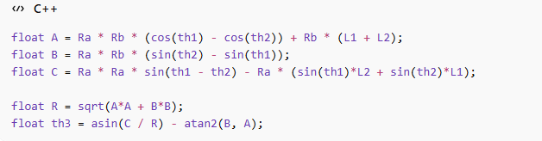
A validity check ensures that the computed configuration is physically feasible:
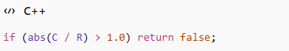

The tail position is computed as:
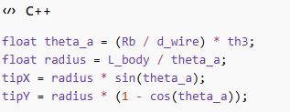

Velocity Estimation and Propulsion
The reel angular velocity is approximated numerically:
$$\begin{aligned}{\dot{θ}}_{3}≈\frac{θ_{3}\left(t\right)-θ_{3}\left(t-Δt\right)}{Δt}\#\left(13\right)\end{aligned}$$
The tail-tip lateral velocity is computed using:
$$\begin{aligned}v_{\text{tip}}=∣\frac{L}{θ_{a}^{2}}\left(\sin{θ_{a}}-θ_{a}\cos{θ_{a}}\right){\dot{θ}}_{a}∣\#\left(14\right)\end{aligned}$$
The swimming speed is then estimated using a proportional model:
$$\begin{aligned}v_{\text{robot}}=k_{\text{thrust}}⋅v_{\text{tip}}\#\left(15\right)\end{aligned}$$

Results and Interpretation
The implementation produces periodic oscillatory motion of the tail, resulting in a stable forward swimming velocity. The symmetric mode generates balanced lateral motion, confirming that the robot moves in a straight line without directional bias.
The results demonstrate that the derived kinematic model is consistent with the expected behavior of a biomimetic fish robot.

Discussion
The model successfully integrates kinematics and motion generation; however, several simplifications are present:
- Hydrodynamic effects are not explicitly modeled
- The propulsion model is simplified and experimentally tuned
- The tail is approximated as a constant curvature arc
- Numerical differentiation introduces approximation error
Despite these limitations, the model provides a computationally efficient framework for simulating robotic fish motion.

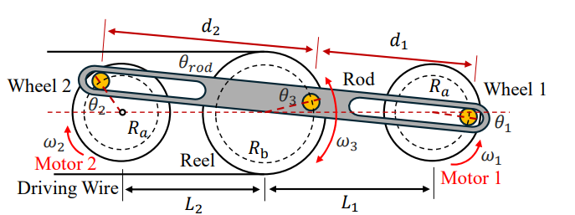
Figure 3: Coordinate systems and kinematic parameters of the fish robot
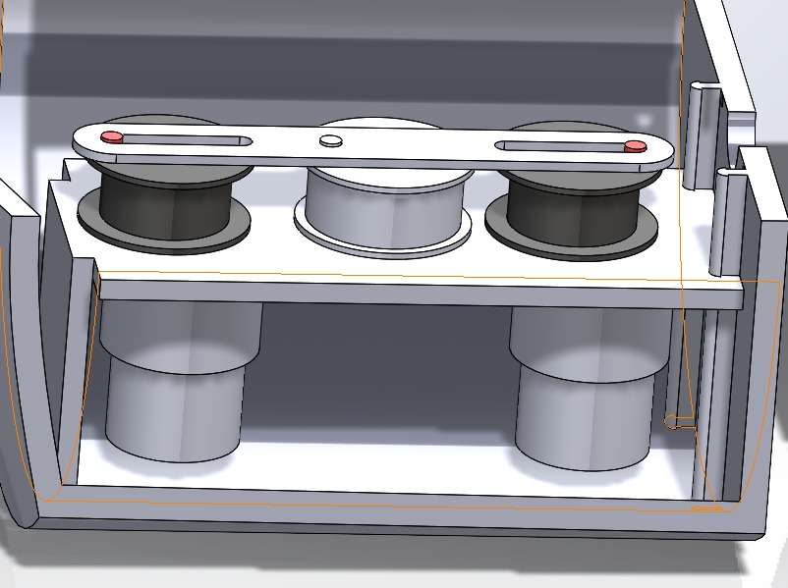
Figure 4: CAD Model of the Dual-Crank Reel Mechanism for Tail Actuation

Symmetric Motion Case (Forward Motion)
In the implemented test case, both motor angles are set equal ($θ_{1}=θ_{2}$), corresponding to a symmetric actuation mode. Under this condition, the forward kinematics equations simplify significantly. From the definitions:
$$\begin{aligned}A=R_{a}R_{b}\left(\cos{θ_{1}}-\cos{θ_{2}}\right)+R_{b}\left(L_{1}+L_{2}\right),B=R_{a}R_{b}\left(\sin{θ_{2}}-\sin{θ_{1}}\right)\#\left(16\right)\end{aligned}$$

since $θ_{1}=θ_{2}$, it follows that:
$$\begin{aligned}\cos{θ_{1}}-\cos{θ_{2}}=0,\sin{θ_{2}}-\sin{θ_{1}}=0\#\left(17\right)\end{aligned}$$

Thus, reducing the expressions to:
$$\begin{aligned}A=R_{b}\left(L_{1}+L_{2}\right),B=0\#\left(18\right)\end{aligned}$$
This simplification indicates that the mechanism operates in a symmetric configuration, where both sides of the system move identically. As a result, the generated motion produces a balanced tail deformation, leading to straight-line swimming behavior. This mode is typically used for forward propulsion, as it avoids lateral bias in the motion of the tail.

Non-symmetric Motion Case (Turning Motion)
In the asymmetric mode, the two motors operate under different conditions: Motor 1 rotates continuously at angular velocity ω, while Motor 2 is held fixed at a constant angle θ₂ = φ, where φ is a chosen steering offset. The reel angle θ₃ therefore becomes a function of both the fixed position φ and the rotating input ω·t:
$$\left[θ_{3}​,{θ˙}_{3}​\right]=f2​\left(φ,ω\right)$$

Reduction of the Collinearity Constraint
Returning to the general closed-form coefficients derived in the Forward Kinematics section (Equations 7–9), and substituting θ₂ = φ while letting θ₁ = ω·t:
$$\begin{aligned}A=R_{a}​R_{b}​\left(cos\left(ωt\right)-cosφ\right)+​R_{b}​\left(L1​+L2​\right)\#\left(19\right)\end{aligned}$$

$$\begin{aligned}B=R_{a}​R_{b}​\left(sinφ-sin\left(ωt\right)\right)\#\left(20\right)\end{aligned}$$

$\begin{aligned}C=R_{a}^{2}sin\left(ωt-φ\right)-R_{a}\left(sin\left(ωt\right)L_{2}​+sinφL_{1}\right)\#\left(21\right)\end{aligned}$like the symmetric case, A and B oscillate with time as Motor 1 rotates. This means the reel angle θ₃ oscillates about a non-zero mean angle determined by φ. The reel angle is still obtained from Equation (10):
$$\begin{aligned}θ_{3}=\arcsin\left(\frac{C}{\sqrt{A^{2}+B^{2}}}\right)-\operatorname{atan}\left(B,A\right)\#\left(22\right)\end{aligned}$$

Mean Oscillation Angle
Fixing Motor 2 at φ ≠ 0 introduces a DC bias into the reel oscillation. To visualize this, consider that when φ = 0 the mechanism is symmetric and θ₃ oscillates symmetrically about zero, producing a straight tail trajectory. When φ ≠ 0, the midpoint of the reel's oscillation shifts away from zero. The mean tail deflection $θ_{3}^{-}$ angle follows from Equation (11):
$$\begin{aligned}θ_{a}^{-}=\frac{R_{b}}{d}θ_{3}^{-}\#\left(23\right)\end{aligned}$$

where $θ_{3}^{-}$ is the time-averaged reel angle over one full rotation of Motor 1. A positive φ shifts the mean tail deflection to one side, generating a lateral force imbalance that causes the robot to turn.

Decoupling of Propulsion and Steering
This mode achieves the central design goal of the 2-DoF mechanism: propulsion and steering are controlled by independent inputs.
- Motor 1 (rotating at ω): controls the oscillation frequency and thus the tail-beat speed and forward thrust, independently of direction.
- Motor 2 (fixed at φ): controls the mean oscillation angle of the tail, and thus the turning direction and radius, independently of speed.
The swimming speed and yaw direction of the robot can therefore be expressed jointly as:
$v_{robot}​,ψ_{robot}​]=g_{2}​(θ_{3}​,{θ˙}_{3}​)=g_{2}​(f_{2}​(φ,ω))$ (24)

where g₂ is the same propulsion mapping used in the symmetric case (Equations 14–15), now evaluated on the asymmetric reel output.
Turn Direction
The sign of φ determines the direction of the bias and therefore the direction of turning:
- φ < 0 (e.g., φ = −π/2): the tail is biased toward the right side of the body → the robot turns right
- φ > 0 (e.g., φ = +π/2): the tail is biased toward the left side of the body → the robot turns left
- φ = 0: reduces to the symmetric case (Equation 18), and the robot swims straight
This relationship is consistent with the paper's experimental result, where fixing Motor 2 at −90° produced a turning radius of 0.56 m (1.12 BL) completing one full circle in 14 seconds.

Hardware and Programing Implementation

Hardware
For the implementation of the robot, we decided to use:
- Arduino nano 3.0
- Dual Channel DC Motor Driver L298N
- DC Motor with Gearbox and Encoder JGB37-520 12V 178RPM
- Lipo Battery 3S 30C 1800mAh
- 3S Lipo Battery Balance Charger
- 12V to 5V voltage converter
The following is the circuit diagram for the robot.
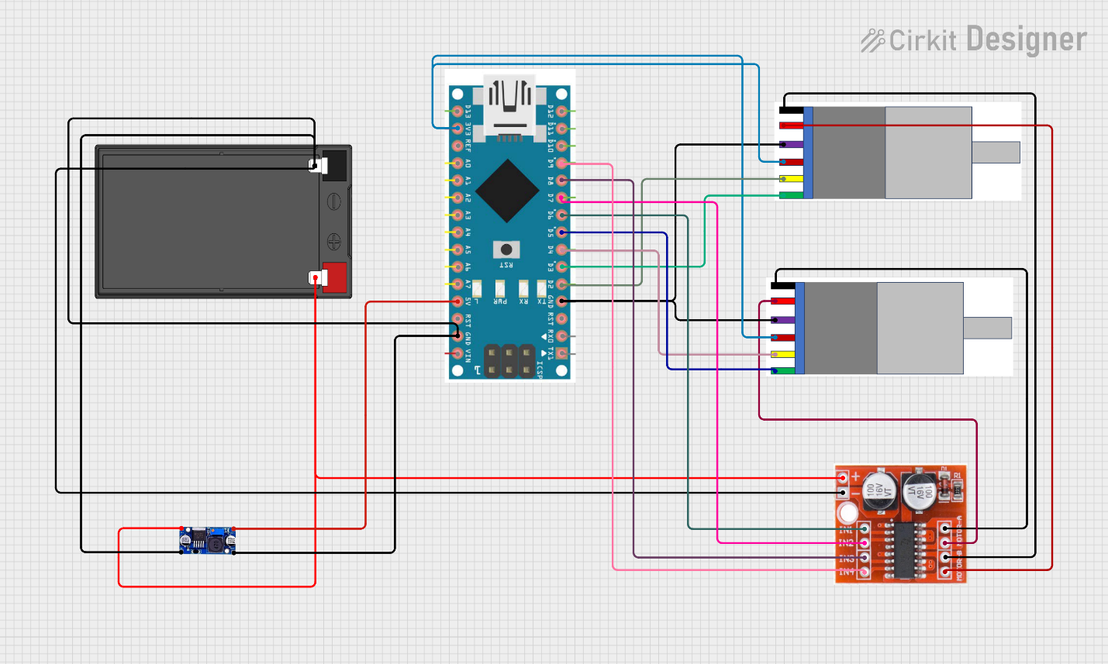
Figure 5: Circuit Design

Programing and Control Algorithm
The control algorithm is implemented on an Arduino nano 3.0 and structured around a fixed 20 Hz interrupt-driven loop. The system reads both motor encoders at each tick, computes forward kinematics, and updates the motor controllers accordingly.

Encoder Feedback
Each JGB37-520 motor is equipped with a Hall effect encoder rated at 20 pulses per revolution (PPR). Quadrature decoding is applied by monitoring both encoder channels on interrupt pins, yielding an effective resolution of 80 counts per revolution. From the encoder count delta over the control period ΔT, the angular position θ and angular velocity ω of each motor are derived as:
θ = (counts / 80) · 2π
ω = Δcounts / (80 · ΔT) · 2π

Motor 1 with Speed PID
The kinematic model of Wang et al. (2026) treats the angular velocity of Motor 1 as a constant input ω. This assumption breaks down in practice when the motor slows under load, directly corrupting the FK computation and the swimming speed estimate. To enforce the constant-ω assumption at the hardware level, Motor 1 is governed by a single-loop speed PID:
error₁ = ω_{target} − ω_{measured}
The output drives the L298N PWM signal such that the measured angular velocity tracks the commanded tail-beat frequency regardless of load variation.

Motor 2 with Cascaded Position–Speed PID
Motor 2 must hold a fixed angular position φ during asymmetric mode while the elastic spine continuously exerts a restoring torque against it. A single position loop reacts to the resulting angular displacement only after the error has already grown, producing sluggish and oscillatory holding behavior. To address this, a cascaded (inner–outer) PID structure is used.
The outer loop operates on position error and outputs a commanded angular velocity:
error_{pos} = φ_{target} − φ_{actual}
ω_{commanded} = PID_{outer}(error_{pos})
The inner loop then tracks that commanded velocity in real time:
error_{spd} = ω_{commanded} − ω_{measured}
PWM = PID_{inner}(error_{spd})
This structure makes the holding behavior stiff — the inner loop actively drives the motor at whatever rate the outer loop requires, counteracting the tail load before significant position error accumulates. The inner speed loop must be tuned to stability first, after which the outer position loop is tuned on top of it.

Control Modes and Sequence
The system operates in two modes derived directly from the kinematic analysis. In the symmetric mode, both motors are commanded to rotate at ω speed, and Motor 2's position setpoint mirrors Motor 1's live encoder reading. In the asymmetric mode, Motor 1's speed PID maintains ω while Motor 2's cascaded PID holds φ at the steering offset. The demo sequence cycles through forward swimming (3 s) → right turn (1 s) → forward (1 s) → left turn (1 s), repeating continuously. All PID integrators are reset at each mode transition to prevent windup carry-over from the previous step.

Conclusion
This project extends the kinematic framework of Wang et al. (2026) while simplifying the hardware and control system for practical implementation. By retaining the 2-DoF crank-slider mechanism, propulsion and steering remain decoupled, ensuring both speed and maneuverability. The replacement of servo-based control with an encoder driven PID algorithm provides smooth and accurate motion using accessible, budget-friendly components. Overall, the work demonstrates that effective robotic fish locomotion can be achieved with streamlined design choices, making advanced biomimetic systems more reproducible and adaptable for future research and applications.

References and Links
- Wang, Y., Chen, C., Chen, Y., Li, J., Motegi, Y., Ohkuma, K., Maki, T., & Zhao, M. (2026). Design, modeling and direction control of a wire-driven robotic fish based on a 2-DoF crank-slider mechanism. arXiv. https://arxiv.org/abs/2603.02851
- Lee, S., Park, J., & Han, C. (2007). Optimal control of a mackerel-mimicking robot for energy efficient trajectory tracking. Journal of Bionic Engineering, 4(4), 209–215. https://doi.org/10.1016/S1672-6529(07)60029-7

- https://dynamic.me/arduino-nano-30-ch340-chip
- https://dynamic.me/dual-channel-dc-motor-driver-pwm-speed-h-bridge-stepper-l298n
- https://dynamic.me/dc-motor-with-gearbox-and-encoder-jgb-37-520-12-v-178-rpm
- https://electroslab.com/products/lipo-battery-3s-30c-1800mah?_pos=4&_sid=d1ff38652&_ss=r
- https://electroslab.com/products/3s-lipo-battery-balance-charger?_pos=5&_sid=d1ff38652&_ss=r
- https://dynamic.me/dc-to-dc-buck-converter-regulator-12-v-to-5-v-3-a-15-w

